Describing and estimating variation in mixed feeds.

INTRODUCTION

A major goal of poultry nutritionists and feed millers is to see that each bird receives the nutrients they need each day. To do that, the feed must be fairly uniform. It must contain adequate amounts of each required nutrient in the amount of feed a bird will eat in a meal or a day.

The composition of feed ingredients is variable due to both genetic and environmental factors. For plant products, different batches are derived from different cultivars and are grown under different climatic, fertilization conditions and then then processed and stored differently. Different batches of animal by-products also differ, mainly because of variation in raw materials and how they are processed.

Once feeds are mixed, it is important that they be sampled properly to assure that that batches of feed contain what they are expected to. Because there is variation inherent in different batches with the same ingredient formula, multiple samples of each batch are necessary to estimate the mean.

When various proportions of feed ingredients are mixed, any samples have properties blended from all the incorporated ingredients.

The variances of mixtures is calculated as follows from the variances of the ingredients:

Suppose *X*i follows a Normal distribution with the mean μi and variance $σ_{i }^{2}, N(μ_{i},σ_{i}^{2})$,

*i* = 1, . . . , k, and suppose *X*i’s are independent. Then

$Y= a_{1}X_{1} +…+ a_{k}X_{k}= \sum_{i=1}^{k}{a_{i}X_{i}}$ [1]

follows a Normal distribution with mean *μ* and variance *σ2*, *N(μ,σ2),* where

[2]

$σ^{2}= a_{1}^{2}σ_{1}^{2}+…+ a_{k}^{2}σ_{k}^{2}= \sum_{i=1}^{k}{a_{i}^{2}σ_{i}^{2}}$ [3]

***How Variable Are Nutrients In A Feed?***

The Microsoft Excel workbook called “FeedVariation.xlsx” was designed to use these formulas. It is available from the Poultry Hub Australia web page under “Research Resources”. A portion of the “Protein Example” worksheet is shown in Figure 1. The ingredients with their average protein levels and standard deviations from samples collected from Australian producers and compiled in the Australian Feed ingredient Database (AFiD).

Figure 1. A portion of the Microsoft Excel workbook called “FeedVariation.xlsx” showing the formulas to calculate the variation a mixed feed from the reported variation in the ingredients.

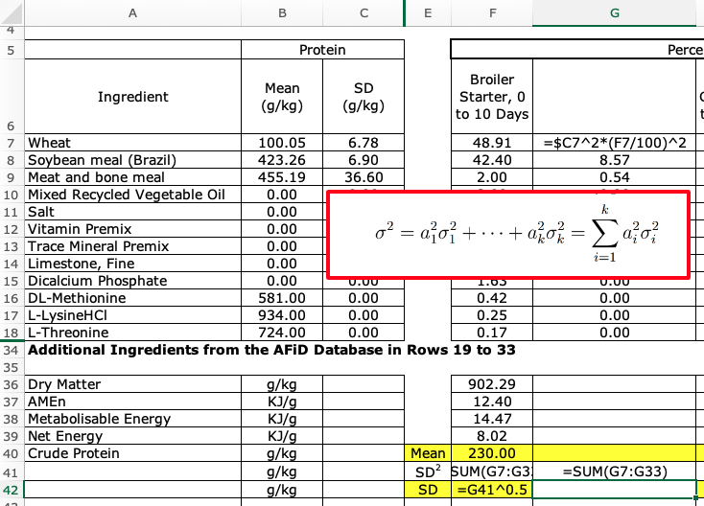

In the right center portion of Figure 2 are some formulas for feeds for different classes of chickens and turkeys, and there are more on the actual worksheet. At the bottom of the worksheet are the calculated averages and standard deviations of the expected crude protein levels of each of the feeds, highlighted in yellow. You can download the workbook and click on each cell to see how the calculations were made consistent with Equation [3] above.

Figure 2. A portion of the Microsoft Excel workbook called “FeedVariation.xlsx” showing the variation in crude protein of mixed feeds from the reported variation in Australian ingredients.



If many batches of Broiler Starter, 0 to 10 Days were mixed from random samples of Australian ingredients, the average crude protein levels of the feeds would be expected to be 230 g/kg CP. Half of the batches would be expected to contain more and half less than 230 g/kg CP.

The normal distribution, defined by the mean and standard deviation could be used estimate the distribution of batches of feed.

Figure 2. The Normal Distribution, from LibreText.

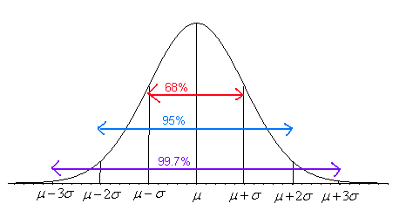

Thirty-four percent of batches of this feed would contain between 230 and 230 - 4.48 = 225.52 g/kg CP; 13.5 % of batches of feed would contain between 225.52 and 225.52-4.48 = 221.04; and 2.5 % of batches of feed would contain less than 221.04 g/kg CP.

Poultry producers often purchase ingredients from the same supplier, so the variation in some ingredients may be less than what would be expected from the AFiD database. None the less, this analysis points out the importance of monitoring ingredients to decrease variation as much as possible. Limiting variation in mixed feeds is important when the producer is feeding their own birds, but even more important when the producer is selling feed and the customer expects each batch to have a specified minimum amount of each nutrient. Using average values may not be acceptable to the customer.

REFERENCE

Moss, A. Australian Feed Ingredient Databasehttps://agrifutures.com.au/product/database-of-the-nutrient-content-of-australian-feed-ingredients/